Intro Copy (Needs Refined): Capture the real-world signals that impact your business the most
Image 1: Overhead Building Map
Highlight Signal Hotspots like restrooms, lobby areas, conference rooms, etc.
Zoom in on restrooms
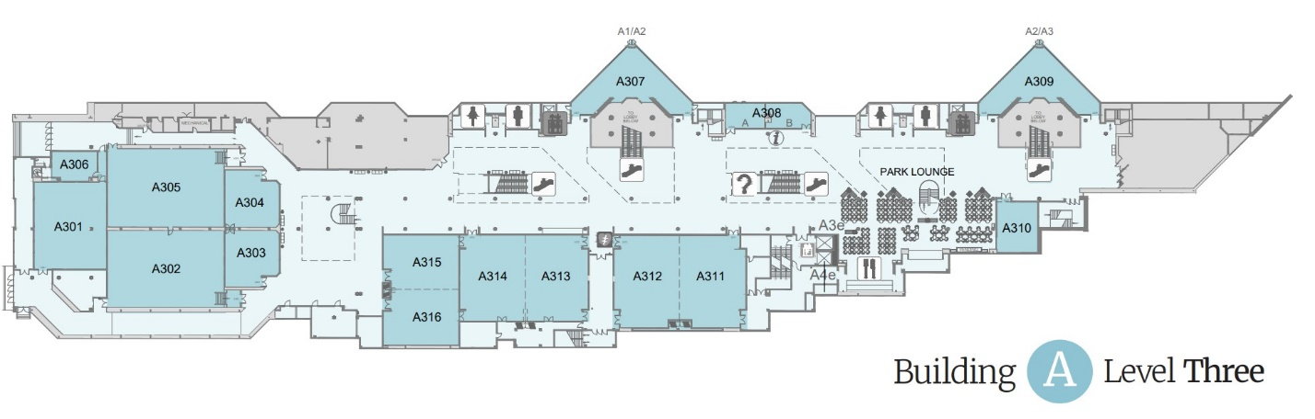
Copy (Needs refined): Frictionless devices capture important time and location information, so your teams know when and where to respond.
Image 2: Inside Restroom
Highlight Sentiment, Service Display, Foot Traffic Monitor in ceiling as same signal hotspots
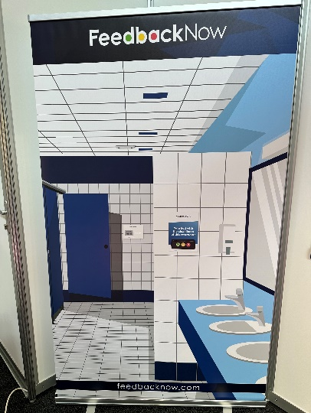
Copy (Needs refined): Captured signals are instantly sent to the platform where they are transformed into usable insights
Third Image: Platform View of Sentiment + Traffic Graph
Can Increase as time goes or stay the same percentages and # of people.
Copy(Needs refined): Teams are instantly alerted when metrics fall outside of acceptable thresholds you set so teams can fix issues immediately.
Fourth Image: Alert Notification
“5 Red Votes in 5 Minutes Men’s Restroom”
Closing Copy(Needs refined): Optimize operations and improve customer experiences with the help of real-time signals from FeedbackNow!

